- February’s bumper increase in GDP means that the UK is likely to see another strong outturn for Q1, repeating the experience of recent years. Residual seasonality is the most likely explanation. Payback for Q1 strength will likely coincide with the peak impact on activity of the Middle East conflict, increasing the chances of a quarterly fall in GDP in H2 2026.
- Members from across the Monetary Policy Committee’s hawk-dove spectrum have preached the need to wait for data before taking a strong view of the impact of the conflict on the monetary policy outlook. This week’s commentary suggests that hikes won’t be under active consideration until at least mid-summer, and we think the MPC will ultimately leave Bank Rate on hold until well into next year.
We’re still at the point when the hard data refers to the period before the Middle East conflict began. On the face of it, the February GDP release suggested the economy was in good health before the war, but we’re sceptical.
The GDP series can often be volatile, but February’s 0.5% m/m increase was extreme. With January also revised up to a 0.1% rise, having previously been flat, this pushed 3m/3m growth to 0.5% in February (Chart 1). But it’s hard to corroborate this strength with other evidence from surveys or high frequency data. So we think the most likely explanation is that there’s still a residual seasonality problem, which will exaggerate the strength of Q1 but then unwind over the rest of the year. Indeed, the payback for the strong Q1 will likely coincide with the peak impact on activity of the Middle East conflict, so the chances of a quarterly fall in GDP in H2 are high. We’ve been doing some further digging into the residual seasonality problem and plan to publish a note on the subject next week.
Chart 1: February’s GDP outturn leaves us on track for another strong Q1
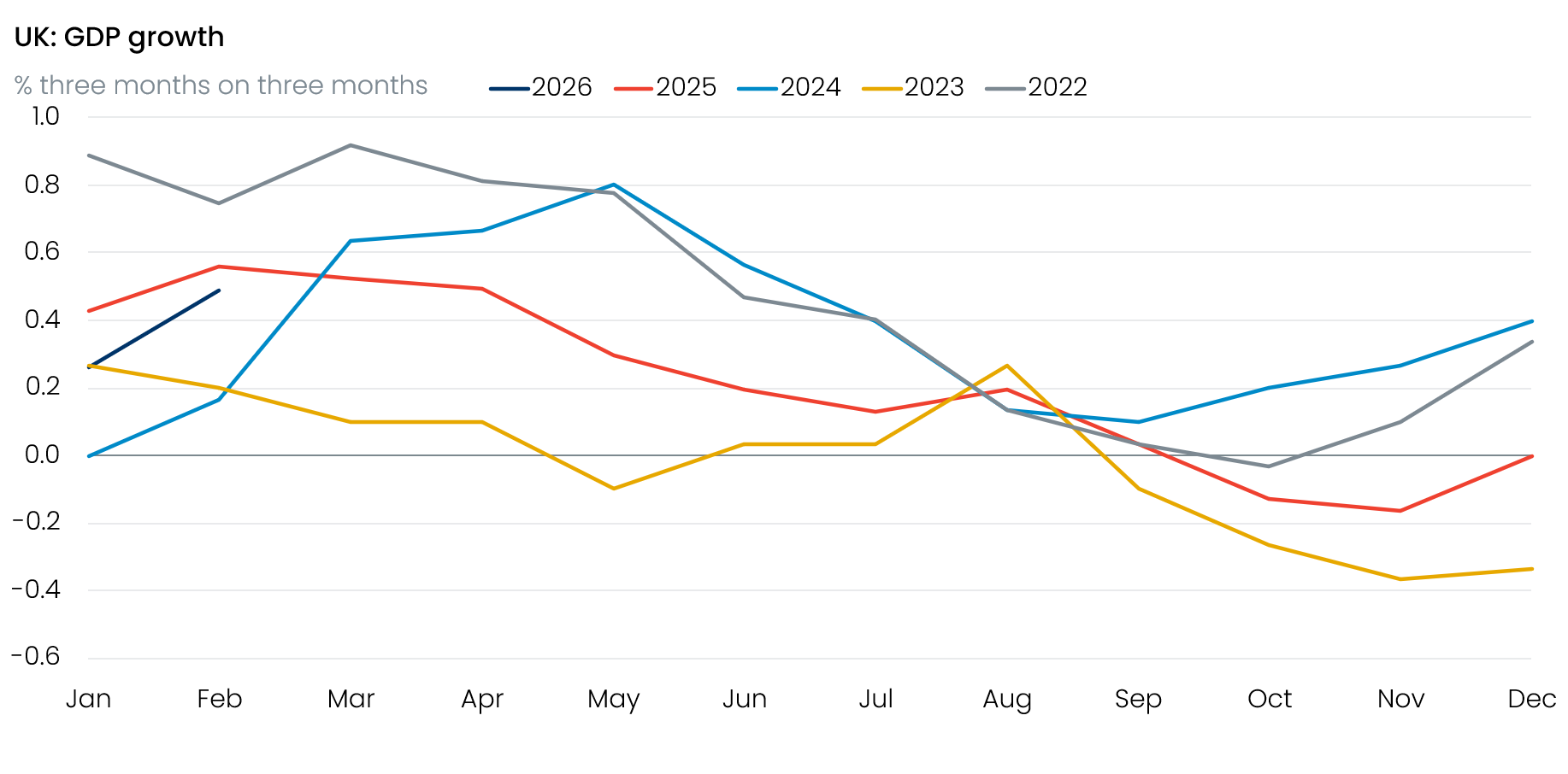
Source: Haver Analytics

Residual seasonality is far from the Office for National Statistics’ only problem. In the construction release published alongside this week’s GDP outturn, the ONS admitted they’d uncovered an error that had caused them to under-estimate the level of construction output by 1.2ppts from January 2022 onwards.
There was also bad news about the timetable for improving the labour market statistics, which have been in a state of disarray since 2023. The timetable for resolving the problems has been pushed back several times already. The ONS had previously said that it might be able to launch its transformed Labour Force Survey in November 2026, but it confirmed this week that this timetable is no longer feasible. The most likely outcome now is a transition at some point in 2027, with the ONS due to judge its readiness by next January at the latest.
The new leadership at the ONS has been more transparent about its problems and shown stronger ambition to implement improvements. But progress remains glacially slow, and the wait for reliable labour market data will now enter a fourth year, an indefensible situation.
The data problems are a particular concern for the Bank of England, given that the tightness of the labour market will be a key input into the Monetary Policy Committee’s judgement about the risk that this year’s bout of high inflation will drive up pay growth.
Several MPC members spoke at events this week. Members at either end of the hawk-dove spectrum, Megan Greene and Alan Taylor, echoed recent comments by Governor Andrew Bailey in suggesting that markets had got ahead of themselves in pricing an aggressive series of rate hikes. In late-March, markets were pricing 64bp of hikes by the July meeting, but that has since been pared back to 23bp now (Chart 2).
Chart 2: Markets have taken a less hawkish view of the future path of interest rates in recent weeks
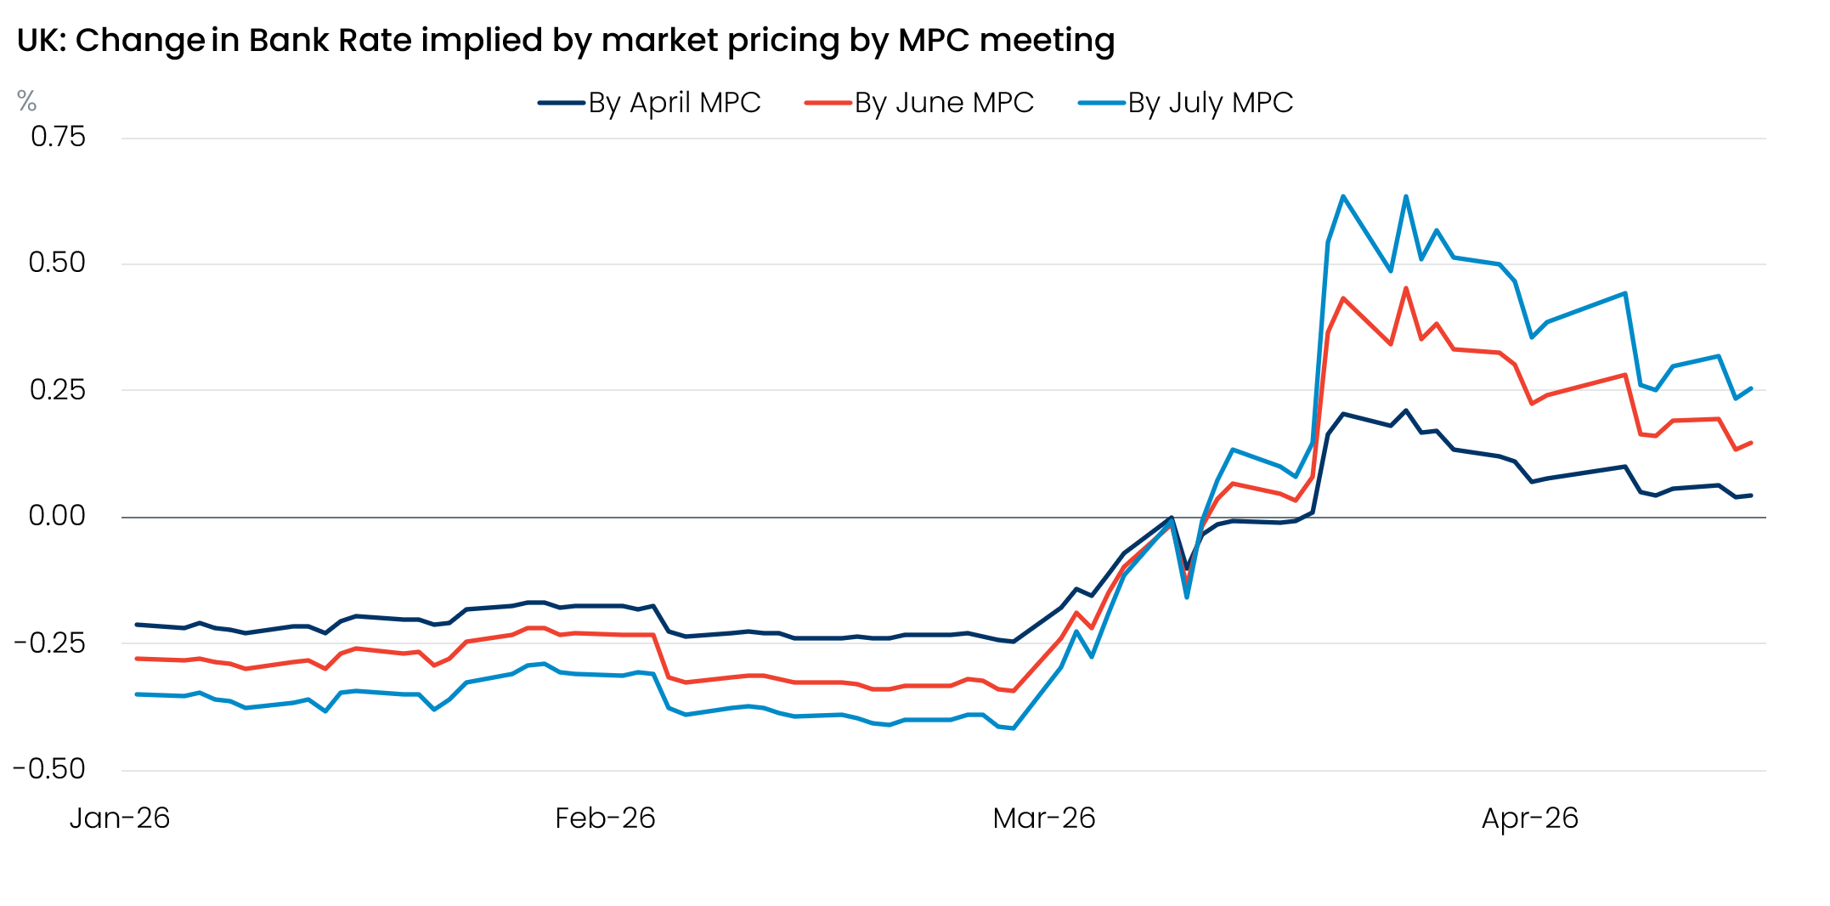
Source: Oxford Economics calculations using data from Haver Analytics
The core message from both hawk and dove was a need to wait for data before taking a strong view on the implications of the conflict for monetary policy, a message that was then repeated by Governor Bailey at the IMF meetings in Washington. We continue to think Bank Rate will remain on hold for a prolonged period. But our senior advisor and former MPC member, Michael Saunders, will publish a note next week looking at what might lead the committee to take a more hawkish approach.

The week ahead
A busy week begins with Tuesday’s labour market release. Last month’s release offered tentative evidence that the jobs market’s deterioration was easing, with a more solid monthly outturn for pay and HMRC reporting successive monthly increases in employee numbers. Next week’s data refers to the period before the Iran conflict, and we forecast that unemployment will have held steady at 5.2% in the three months to February. But very strong readings for pay growth last February mean we think average weekly earnings growth cooled to 3.5% on both the total and regular pay measures.
Wednesday’s inflation release for March will show the first evidence of the impact of the conflict on the hard data. Weekly data from the Department for Energy and Climate Change suggests that petrol prices rose by 9% between February and March. Given that pump prices fell between those months a year ago, this should add 0.2ppts-0.3ppts to inflation in March. We expect the headline rate will have increased to 3.2%, from 3% in February.
Retail sales have been characteristically volatile in recent months, with January’s surge being followed by a partial reversal in February. We think there’s scope for further payback in March’s data, with non-food and non-store sales having further to drop to fall into line with previous trends. We also expect a chunky drop in fuel sales following the surge in prices that month. Overall, we expect retail sales to have fallen by 0.6% m/m in March.
Table 1: Week ahead calendar
Date | Events | Period | Measure | Unit | Previous | Forecast
Apr 21 | LFS unemployment | Dec-Feb | Rate | % | 5.2 | 5.2
Apr 21 | Average earnings (total pay) | Feb | 3m, y/y | % | 3.9 | 3.5
Apr 21 | Average earnings (regular pay) | Feb | 3m, y/y | % | 3.8 | 3.5
Apr 22 | CPI inflation | Mar | m/m | % | 0.4 | 0.5
Apr 22 | CPI inflation | Mar | y/y | % | 3.0 | 3.2
Apr 22 | RPI inflation | Mar | m/m | % | 0.4 | 0.6
Apr 22 | RPI inflation | Mar | y/y | % | 3.6 | 3.8
Apr 22 | Producer input prices | Mar | m/m | % | 0.8 | 4.0
Apr 22 | Producer input prices | Mar | y/y | % | 0.5 | 4.8
Apr 22 | Producer output prices | Mar | m/m | % | -0.5 | 2.0
Apr 22 | Producer output prices | Mar | y/y | % | 1.7 | 3.5
Apr 22 | Land Registry house prices | Feb | y/y | % | 1.3 | 1.1
Apr 23 | Public finances | Mar | PSNB | £bn | 14.3 | 11.0
Apr 23 | S&P Global manufacturing | Apr | PMI | % bal | 51.0 | 50.5
Apr 23 | S&P Global services | Apr | PMI | % bal | 50.5 | 50.0
Apr 23 | S&P Global composite | Apr | PMI | % bal | 50.3 | 49.8
Apr 24 | GfK consumer confidence | Apr | Headline | % bal | -21 | -25
Apr 24 | Retail sales inc fuel | Mar | m/m | % | -0.4 | -0.6
Apr 24 | Retail sales inc fuel | Mar | y/y | % | 2.5 | 0.7
Source: Oxford Economics

Key forecasts
Table 2: UK forecast overview
(ANNUAL PERCENTAGE CHANGES UNLESS SPECIFIED)
 | 2023 | 2024 | 2025 | 2026 | 2027 | 2028
GDP | 0.3 | 1.1 | 1.4 | 0.4 | 0.9 | 1.8
Private consumption | -0.3 | -0.1 | 0.8 | 0.3 | 0.5 | 1.5
Fixed investment | 0.5 | 1.8 | 4.3 | 0.2 | 1.4 | 2.6
Government consumption | 2.1 | 2.9 | 1.7 | 1.9 | 1.6 | 1.4
Consumer prices | 7.3 | 2.5 | 3.4 | 3.9 | 2.6 | 1.7
Unemployment rate (%) | 4.1 | 4.3 | 4.9 | 5.4 | 5.5 | 4.9
Current a/c balance (% of GDP) | -3.6 | -3.0 | -2.4 | -3.7 | -3.2 | -2.7
Government balance (% of GDP) | 5.2 | 5.2 | 5.1 | 4.2 | 3.6 | 2.9
Central bank policy rate (%, EOP) | 5.25 | 4.75 | 3.75 | 3.75 | 3.50 | 3.00
10yr govt. bond yield (%, EOP) | 3.54 | 4.57 | 4.47 | 4.74 | 4.21 | 3.83
Exchange rate (US$ per £, EOP) | 1.27 | 1.25 | 1.35 | 1.29 | 1.30 | 1.30
Exchange rate (euro per £, EOP) | 1.15 | 1.21 | 1.15 | 1.11 | 1.10 | 1.10
Source: Oxford Economics
Table 3: Quarterly forecasts for the UK
 | 2025 |  |  |  | 2026
 | Q1 | Q2 | Q3 | Q4 | Q1 | Q2 | Q3 | Q4
GDP (% year) | 1.8 | 1.4 | 1.3 | 1.0 | 0.5 | 0.4 | 0.3 | 0.4
CPI inflation (% year) | 2.8 | 3.5 | 3.8 | 3.4 | 3.0 | 3.6 | 4.4 | 4.5
Bank Rate (%, EOP) | 4.50 | 4.25 | 4.00 | 3.75 | 3.75 | 3.75 | 3.75 | 3.75
10yr gilt yield (%, EOP) | 4.70 | 4.48 | 4.70 | 4.47 | 4.88 | 4.80 | 4.78 | 4.74
US$ per £ (EOP) | 1.29 | 1.37 | 1.35 | 1.35 | 1.32 | 1.31 | 1.30 | 1.29
Euro per £ (EOP) | 1.20 | 1.17 | 1.15 | 1.15 | 1.14 | 1.14 | 1.12 | 1.11
Source: Oxford Economics

Latest Country Economic Forecast:
March 20, 2026

Recent publications

Data Insights
February’s GDP bounce will be short lived
Middle East war hit confidence in the services sector in March
Manufacturing PMI weighed down by Middle East conflict
National accounts confirm soft performance over H2 2025
Mortgage activity is likely to weaken in the near term

Research Briefings
MPC hunkers down
MPC preview – Middle East war takes March cut off the table
How will central banks respond to the Iran conflict?
OBR forecasts were out of date before they were published
Productivity may be picking up – but not in a good way

Contacts

Oxford Economics' UK team
- Andrew Goodwin – Chief UK Economist – agoodwin@oxfordeconomics.com
- Edward Allenby - Senior UK Economist - eallenby@oxfordeconomics.com

